**The Anti-Math**

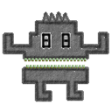

**Pablo Bernal Alarcón**

Youtube link for reference: https://youtu.be/h8rWLLspYpk

**Game Overview:**

The Anti-Math is a game targeted to kids. The purpose of the game is for the user to practice the 4 basic math operations (Addition, Subtraction, Multiplication, Division), by providing a fun and challenging method to do so. It was my PG1 project.

**Platform:**

Unity3D

**Plot:**

The Anti-Math is a monster that is known for chasing people who are bad at math. One day, the Anti-Math finds you and wants to eat you. You as the main character must escape from him by using your math skills to get away from him.

**Objective and Gameplay:**

The player must get to his house before the monster catches up to him. How does he do it? The player is thrown basic math questions by the game, which vary in difficulty depending on how the player chooses. The player then, based upon the question the game gives (say something like “5 + 5 = “), must input the correct answer. If the player gets the question right (by answering “5”, of course) he´ll get one step closer to his house. If he fails, however, he´ll either not move or take a step back. The game ends whenever the player reaches his house or gets caught by the monster.

**What do I want to do with this? (AKA features):**

On the long run, the purpose of this game is to help kids get better at math, love it and not be afraid of it. I had a teacher at school who defined math as an ugly girlfriend: you had to learn to love her. I want to demonstrate everyone (or kids, at least) that math is something beautiful and fun. This is my goal with this small game.

**A lot of Topics to Practice:**

At first I´ll focus on, as I said before, the four basic operations, but in the future I´d really like to experiment by adding a bit of computer science into the mix and add topics such as binary numbers and logic gates.

**Mobile Deployment:**

The idea for this project is to deploy it to mobile phones and tablets (Android is going to be done first), hence the use of Unity, since it makes the upload process to mobile extremely manageable and it´ll allow me to work on other things that may need more attention, such as gameplay and performance.

**Customize Your Game!**

The idea is that the player will be able to customize some things in-game, like choosing between being a boy or a girl, changing the color of the monster, choosing what house they want; fun and small details that´ll make a difference for the kids. It would be fun to take it to the next level eventually and make it so that they can take a pic of their face and that pic would be the main character´s face.

**Multiple Game Modes:**

The game will have two game modes, one of them, which is the original one, consists of the player getting to the house before the monster catches up. The second game mode that I´m thinking of implementing consists of doing an equivalent to an infinite runner, in which the player will get more challenging questions the longer he plays for.

**Below are some screenshots of the original game:**

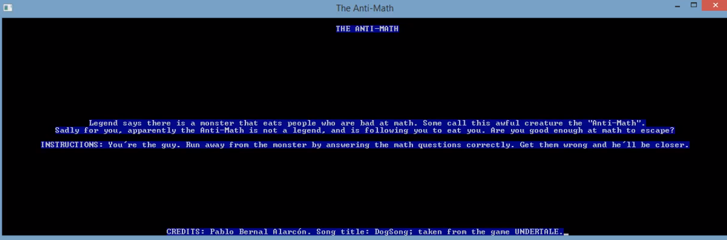

“THE ANTI-MATH --- Legend says there is a monster that eats people who are bad at math. Some call this awful creature the “Anti-Math”. Sadly, for you, apparently the Anti-Math is not a legend, and is following you to eat you. Are you good enough at math to escape? --- INSTRUCTIONS: You´re the guy. Run away from the monster by answering the math questions correctly. Get them wrong and he´ll get closer”.

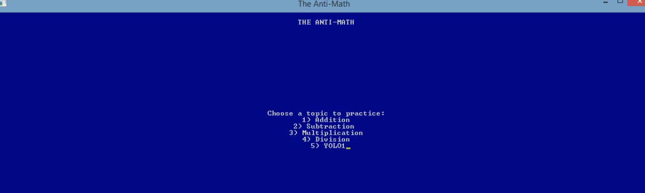

“Choose a topic to practice: 1) Addition, 2) Subtraction, 3) Multiplication, 4) Division, 5) Yolo!”

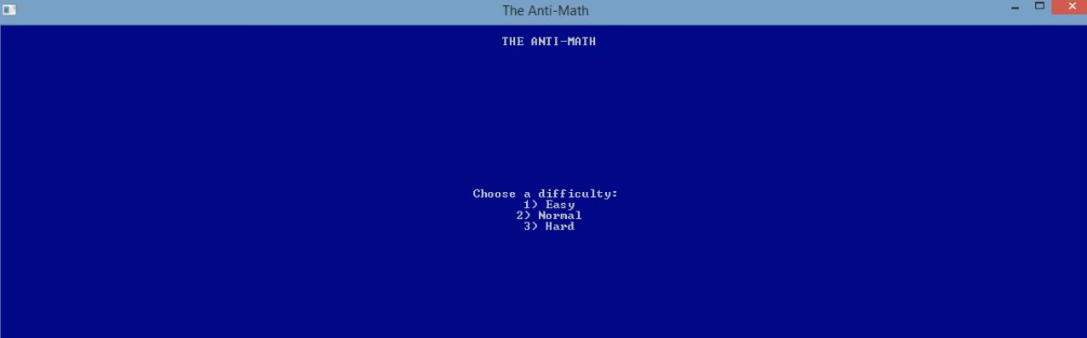

“Choose a difficulty: 1) Easy, 2) Normal, 3) Hard”

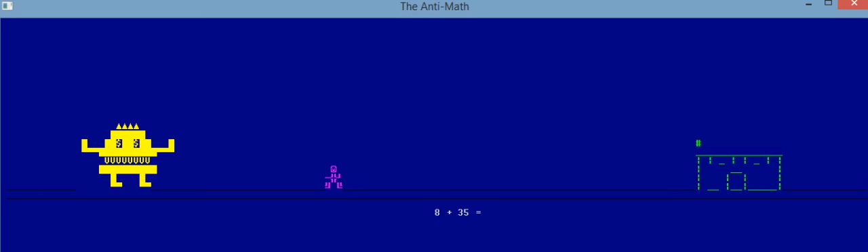

In-game footage

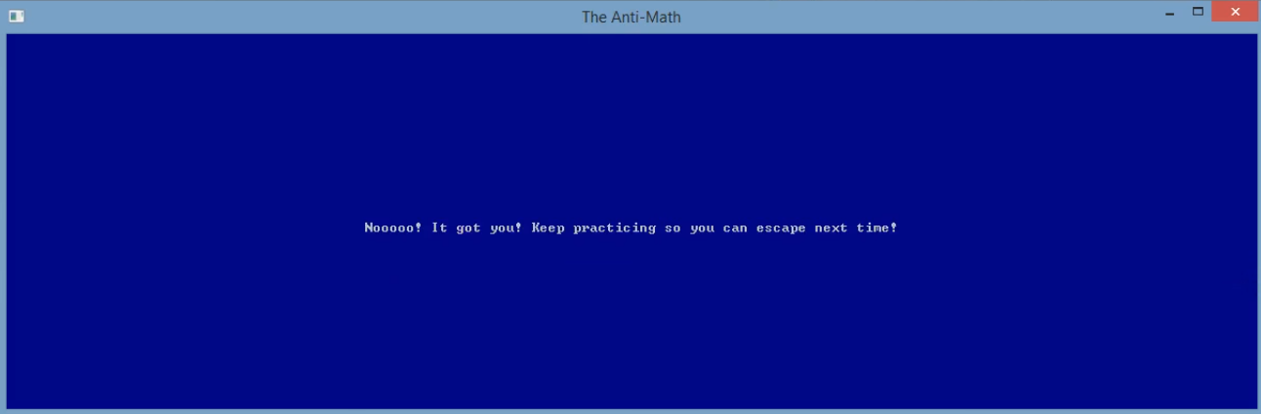

Losing Scene: “Nooooo! It got you! Keep practicing so you can escape next time!”

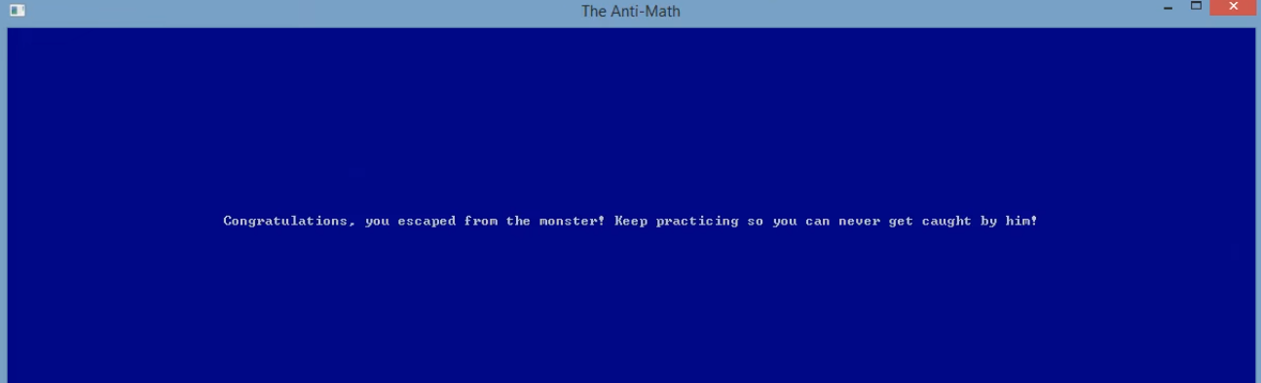

Winning scene: “Congratulations, you escaped from the monster! Keep practicing so you can never get caught by him!”